DataTable

Structure

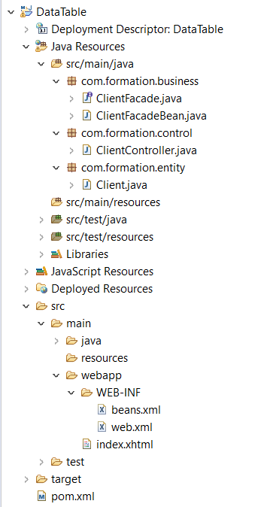

Création du projet
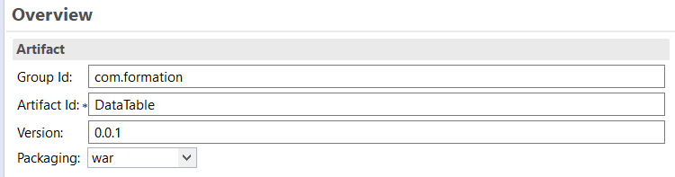
Ajouter les dépendances suivantes dans le fichier pom.xml:
<!-- javaee-web-api -->
<dependency>
<groupId>javax</groupId>
<artifactId>javaee-web-api</artifactId>
<version>8.0</version>
<scope>provided</scope>
</dependency>
<!-- cdi-api -->
<dependency>
<groupId>javax.enterprise</groupId>
<artifactId>cdi-api</artifactId>
<version>2.0</version>
<scope>provided</scope>
</dependency>
<!-- weld-servlet -->
<dependency>
<groupId>org.jboss.weld.servlet</groupId>
<artifactId>weld-servlet</artifactId>
<version>2.4.4.Final</version>
</dependency>

bean.xml

<beans xmlns="http://xmlns.jcp.org/xml/ns/javaee"
xmlns:xsi="http://www.w3.org/2001/XMLSchema-instance"
xsi:schemaLocation="http://xmlns.jcp.org/xml/ns/javaee http://xmlns.jcp.org/xml/ns/javaee/beans_1_1.xsd"
version="1.2" bean-discovery-mode="annotated">

<!-- some content -->
</beans>

Code Java

Entity

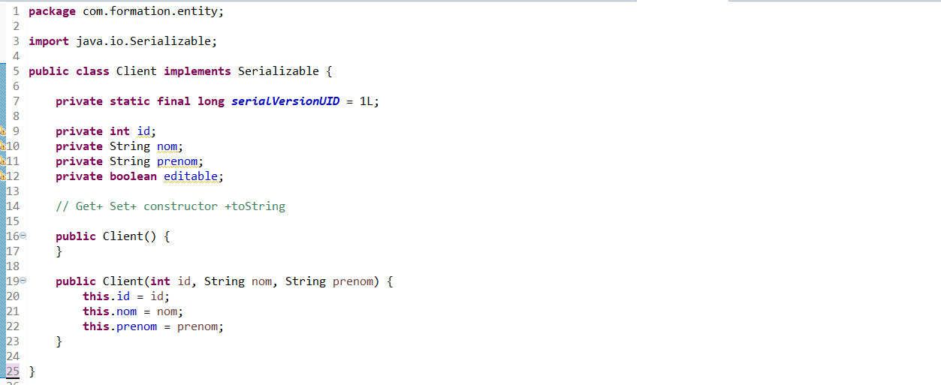

Interface du service

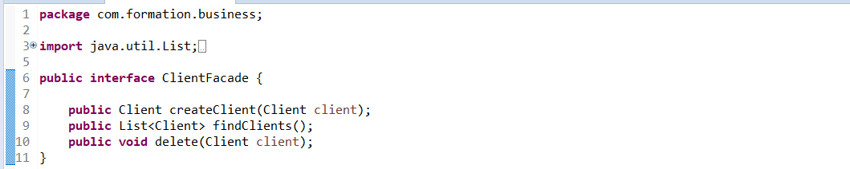

Service Implémentation

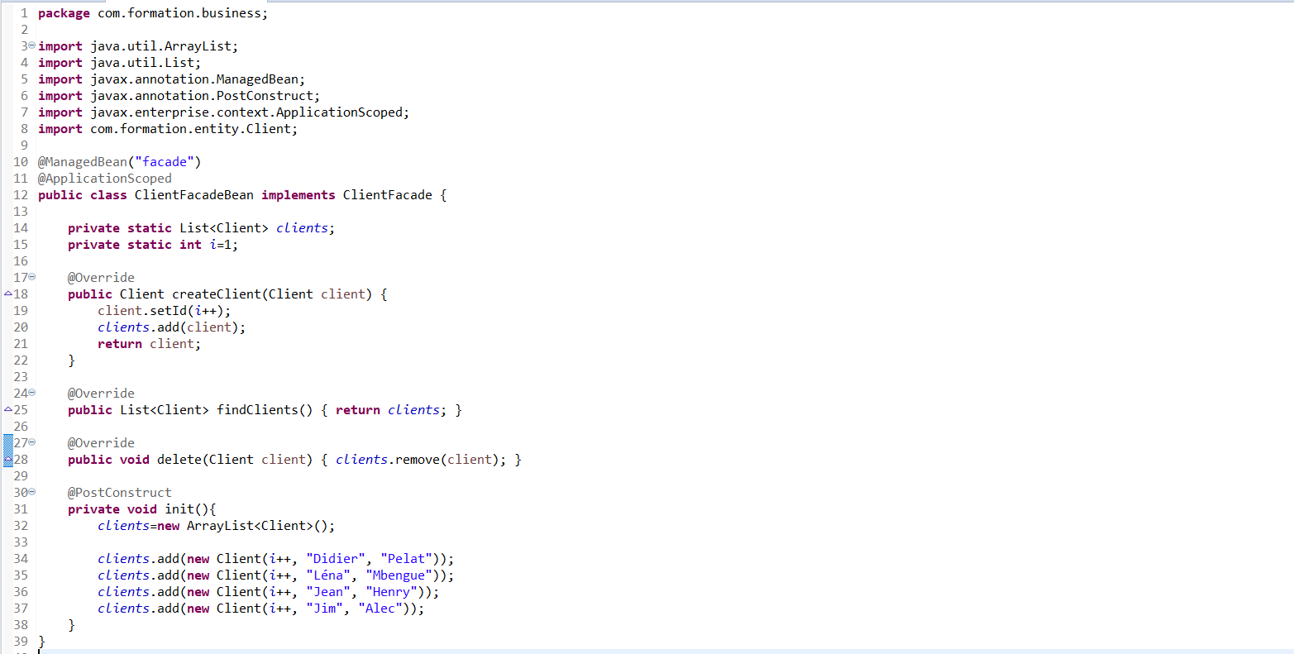

ClientController

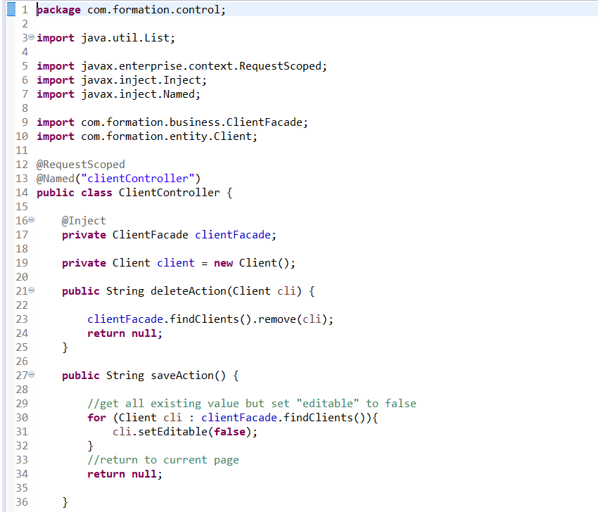

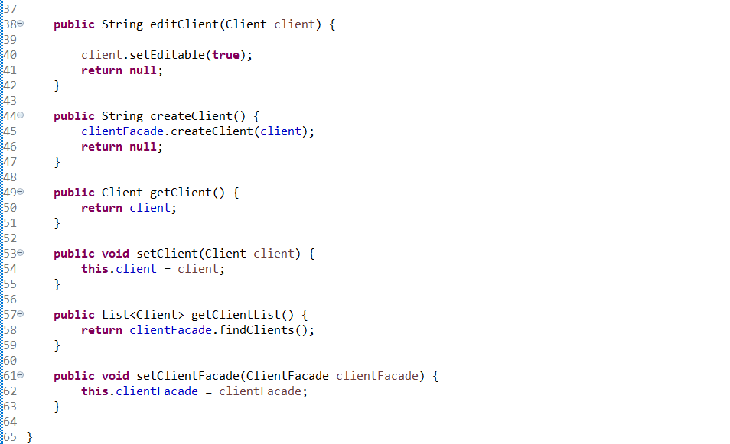

index.xhtml

<html xmlns="http://www.w3.org/1999/xhtml"
xmlns:f="http://xmlns.jcp.org/jsf/core"
xmlns:h="http://xmlns.jcp.org/jsf/html"
xmlns:ui="http://xmlns.jcp.org/jsf/facelets">

<h:head>

</h:head>
<h:body bgcolor="white">
<h1>Create a new Client</h1>
<hr />
<h:form>
<table>
<tr>
<td><h:outputLabel value="NOM : " /></td>
<td><h:inputText value="#{clientController.client.nom}" /></td>
</tr>
<tr>
<td><h:outputLabel value="PRENOM : " /></td>
<td><h:inputText value="#{clientController.client.prenom}" /></td>
</tr>
</table>
<h:commandButton value="New Client"
action="#{clientController.createClient}" />
</h:form>

<hr />
<h1>Liste des clients</h1>
<hr />
<h:form>
<h:dataTable value="#{clientController.clientList}" var="c">

<h:column>
<!-- column header -->
<f:facet name="header">
<h:outputLabel value="ID" />
</f:facet>
<!-- row record -->
<h:inputText value="#{c.id}" size="10" rendered="#{c.editable}" />
<h:outputText value="#{c.id}" rendered="#{not c.editable}" />
</h:column>

<h:column>
<f:facet name="header">
<h:outputLabel value="NOM" />
</f:facet>
<h:inputText value="#{c.nom}" size="10" rendered="#{c.editable}" />
<h:outputText value="#{c.nom}" rendered="#{not c.editable}" />
</h:column>

<h:column>
<f:facet name="header">
<h:outputLabel value="PRENOM" />
</f:facet>
<h:inputText value="#{c.prenom}" size="10" rendered="#{c.editable}" />
<h:outputText value="#{c.prenom}" rendered="#{not c.editable}" />
</h:column>

<h:column>
<f:facet name="header">Action</f:facet>
<h:commandLink value="Edit" action="#{clientController.editClient(c)}" rendered="#{not c.editable}" />
</h:column>

<h:column>
<f:facet name="header">Action</f:facet>
<h:commandLink value="Delete" action="#{clientController.deleteAction(c)}" />
</h:column>
</h:dataTable>

<h:commandButton value="Save Changes" action="#{clientController.saveAction()}" />
</h:form>
</h:body>
</html>

Test

